Que 1) Plot a histogram, 10, 13, 18, 22, 27, 32, 38, 40, 45, 51, 56, 57, 88, 90, 92, 94, 99

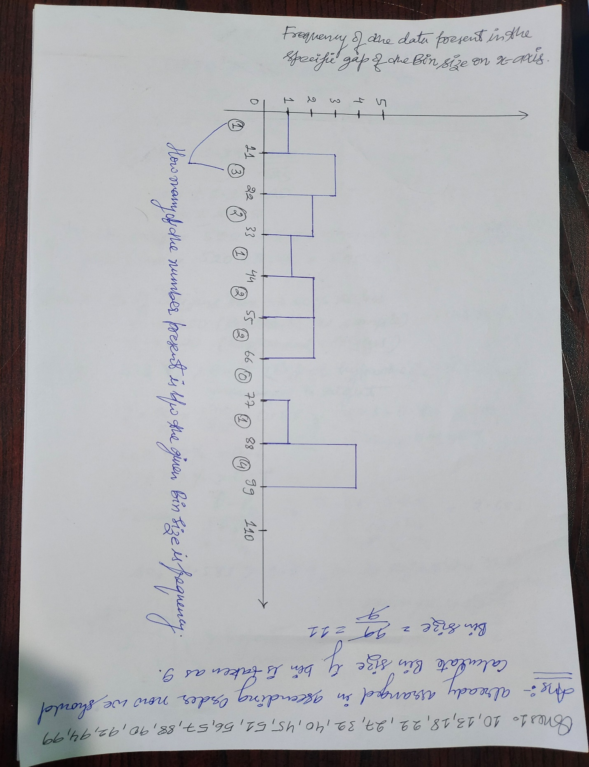

Que 2) In a quant test of the CAT Exam, the population standard deviation is known to be 100. A sample of 25 tests taken has a mean of 520. Construct an 80% CI about the mean.

Que 3) A car believes that the percentage of citizens in city ABC that owns a vehicle is 60% or less. A sales manager disagrees with this. He conducted a hypothesis testing surveying 250 residents & found that 170 residents responded yes to owning a vehicle.

1. State the null & alternate hypothesis.
2. At a 10% significance level, is there enough evidence to support the idea that vehicle owner in ABC city is 60% or less.

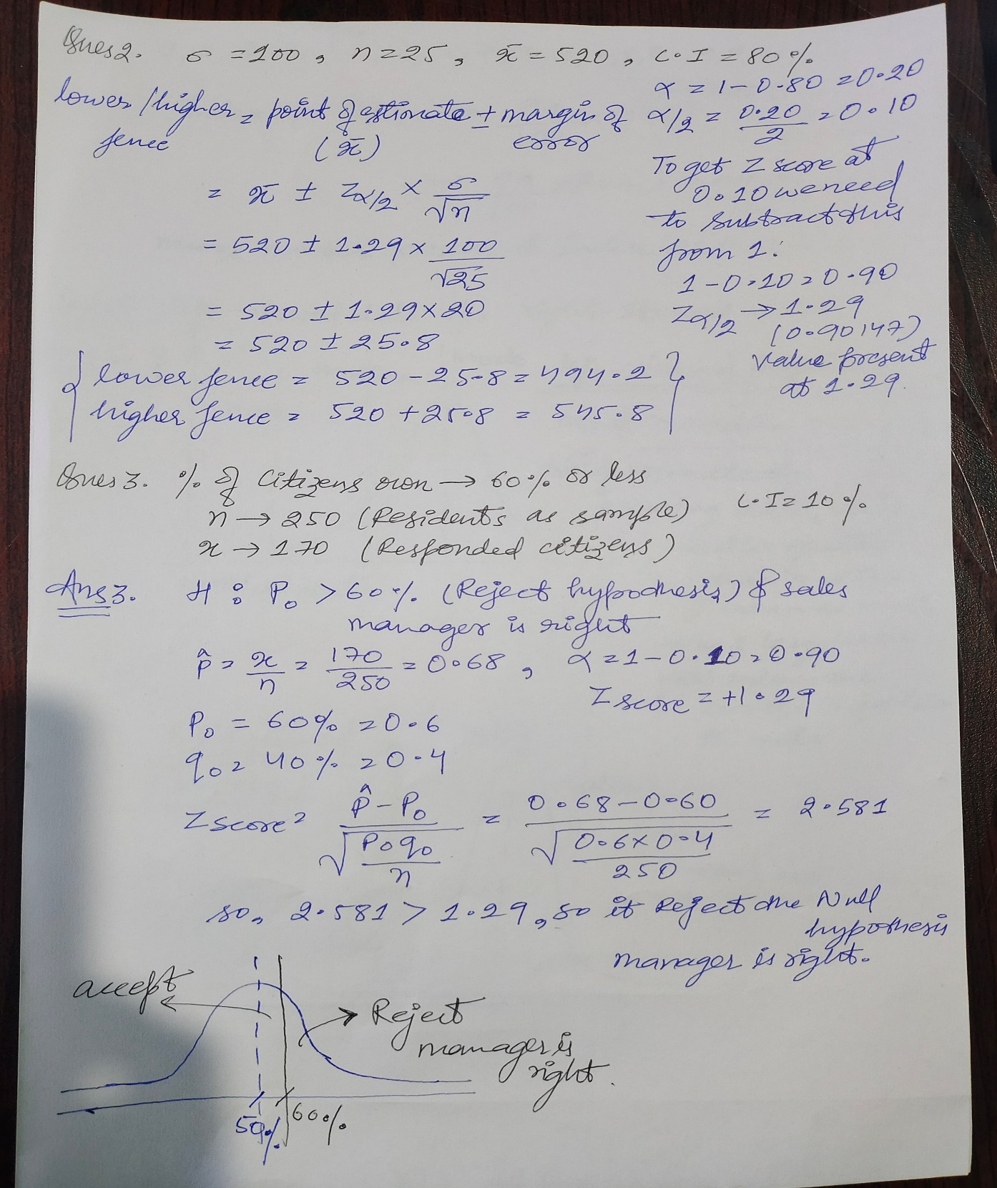

Que 4) What is the value of the 99 percentile? 2,2,3,4,5,5,5,6,7,8,8,8,8,8,9,9,10,11,11,12

Que 5) In left & right-skewed data, what is the relationship between mean, median & mode?

Draw the graph to represent the same.

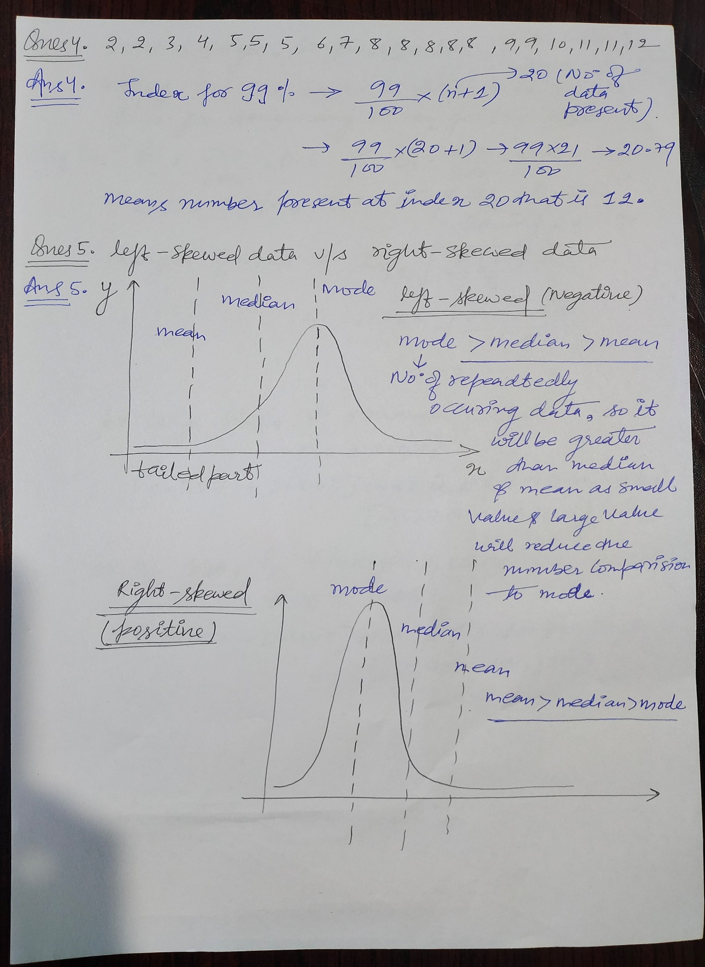

Ques6) 100k employees shirt have to be bought HR game data for 500 from which 300 order large size and 200 order XL size. CI = 95% find the range in which how much shirt should be ordered for L and XL size?

